Lab: Linux and Linux Shell
Lab for the "Containers and Clouds" course @ SoftUni

Configure Connectivity of the VM
The first step is to open the link – https://labs.play-with-docker.com/. 
Then press the [Login] button and click on "docker". A new dialog box opens, which is for docker registration. If you don't have a registration click on [Sign Up]. You have to create an account with a username, password and email. Then sign in to your account. It takes you to a page to select the plan you want – click on "Continue to Free" (Personal plan). Log in to the email you registered with and confirm your account. You may need to reload the page until you see this:

Click on the [Start] button.
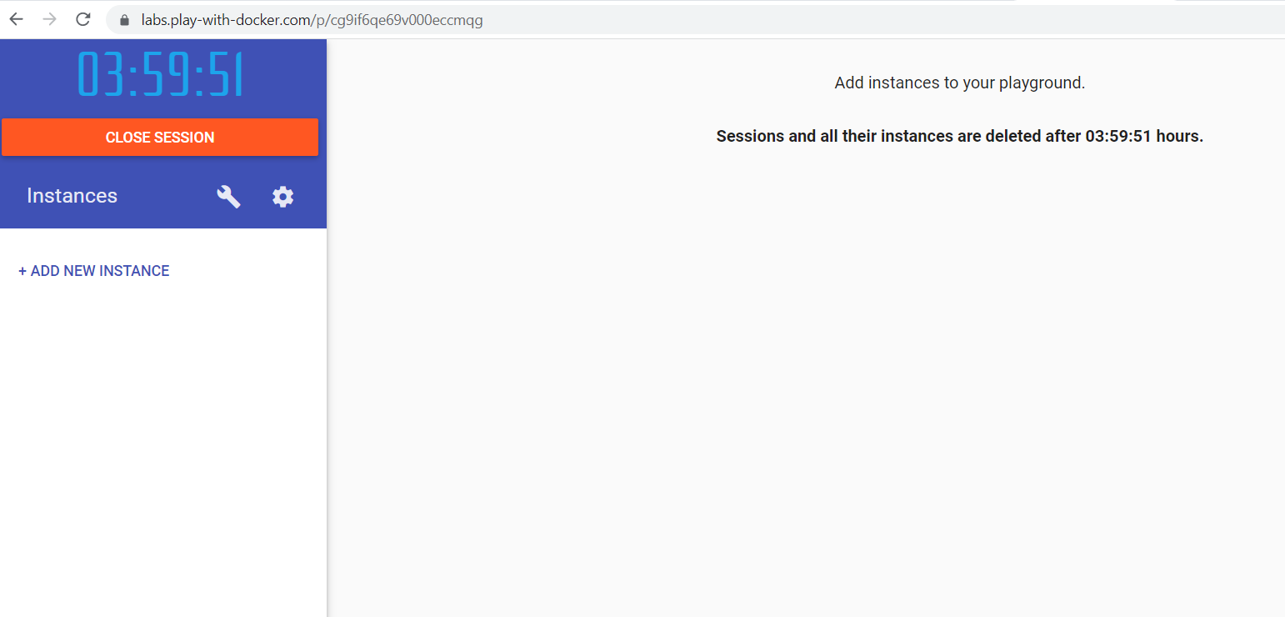
You should see this. Click on [+ add new instance].
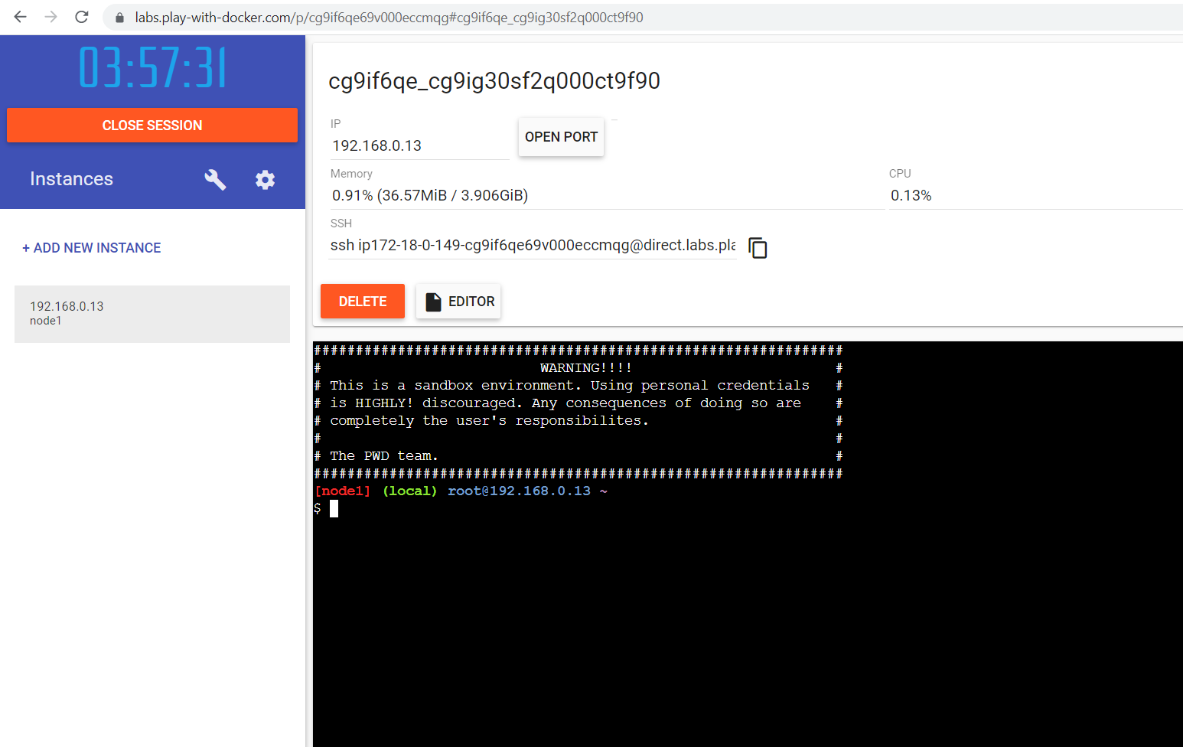
We are ready for work!

Getting to Know the Console
Let's start writing the command in the docker playground.
On the prompt, we can input the user and password that we created during the installation. Of course, we can use the root user, but it is not considered a good practice.
Now, let’s check where (in which folder) we are with the pwd command:
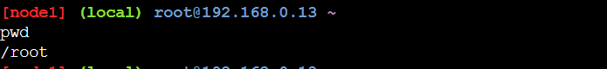
It appears that we are in our home folder (/home/lsauser).
Check what we have here:
There is nothing or at least it appears to be this way. Of course, what we will see here on a clean new installation depends on what distribution we chose and what settings there are by default.
Even though we are not familiar with all options on the ls command yet, let's check if there are any hidden files and folders with:
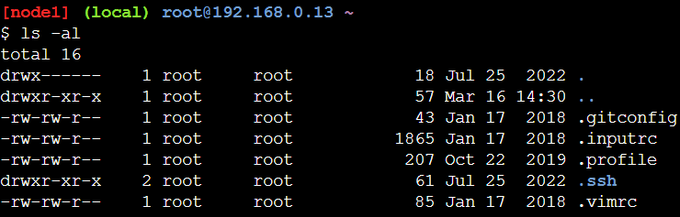
Note that you can autocomplete commands by clicking the [Tab] button twice (Tab-Tab).
So, there are some files after all. Those are considered hidden files, because their name starts with the dot symbol (.). The same rule applies to folders as well.
Now, let's execute this:
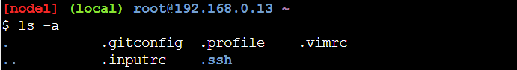
We can also give arguments, not only options. For example, we can check what we have in the main (root) folder. The "/" symbol is used to state that we want to access the root of our file system:
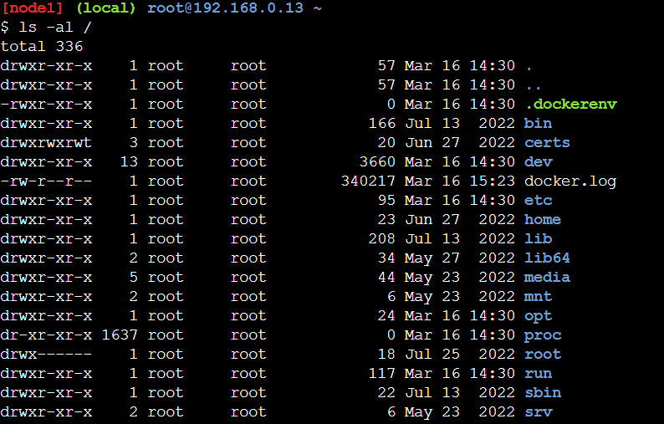
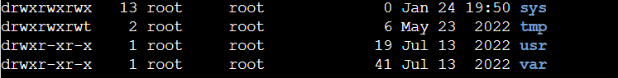
We can note that there is a folder named "/root". This is the home folder for the root user.
Let's change the folder. For example, go to the "/etc" folder. This is the place where most of the configuration files are stored. Then we can check if indeed we changed the folder:
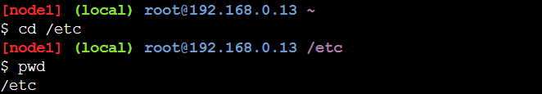
As we can see, there is no need to execute pwd. The prompt reflects or shows where in the file system tree we are currently.
When we want to address all files which name starts with something, no matter what, and how many symbols their name contains, we can use the "*" symbol. For example, ask for all files starting with "os*":
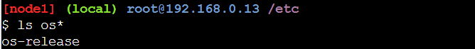
Okay, now that we know that this file exists, let's check what it contains (the actual output may be different):
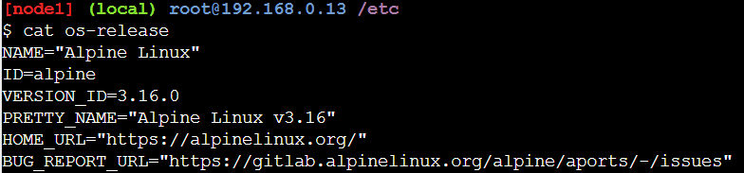
It appears, that this file contains detailed information about our distribution.
Similar or additional information about the distribution we can get by executing:
Beside the information about the kernel, we can extract information about the name of the host:
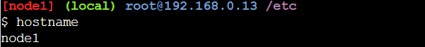
Now, let's return to our home folder:
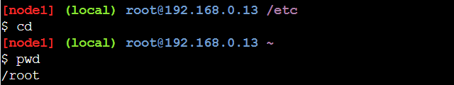
As we can see, if we execute the cd command without any arguments, the result is that we are "back home". There is also a special symbol that we can use – it is again the tilde symbol – "~".
Now, let's try a different approach. In general, no matter what distribution we use, there is a common set of commands that is always available.
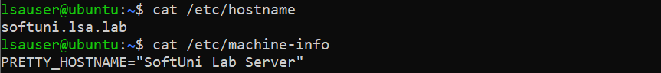
In order the changes to be reflected in the prompt, we must close the session, and open a new one. So, type logout and log back in:
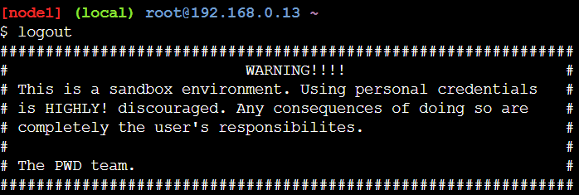
We can see that the new name is applied.
Now, we can check what date is today and what is the time now:
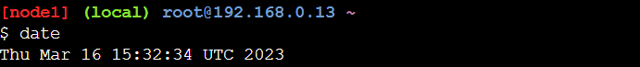
There is a way to modify the output of the date command:
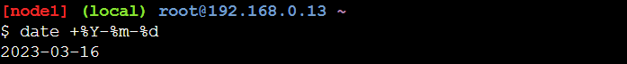
This way, we will receive the current date, represented in "YYYY-MM-DD" format.
Should we need a calendar on the command line, we can have it easily with:
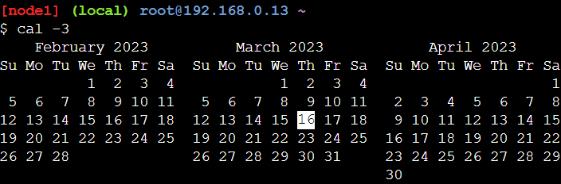
If we need to know since when or how long our system is operating, we can do it with:
At any point we can ask for the history of executed commands:
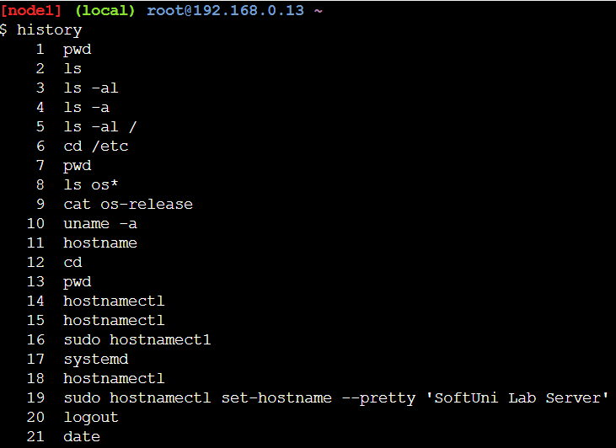
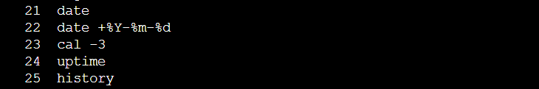
If we want to end our session, we can do it with either exit or logout. Issuing any of these will close our session but will leave the machine up and running. Let's type exit and press the [Enter] key. Our session is closed now:
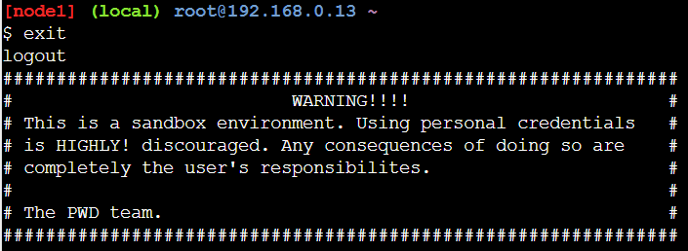
Now log in back again and ask for all files (including hidden ones) in our home folder:
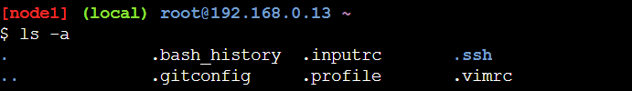
It appears that there is a special file that takes care for our history – .bash_history. Let's check its contents:
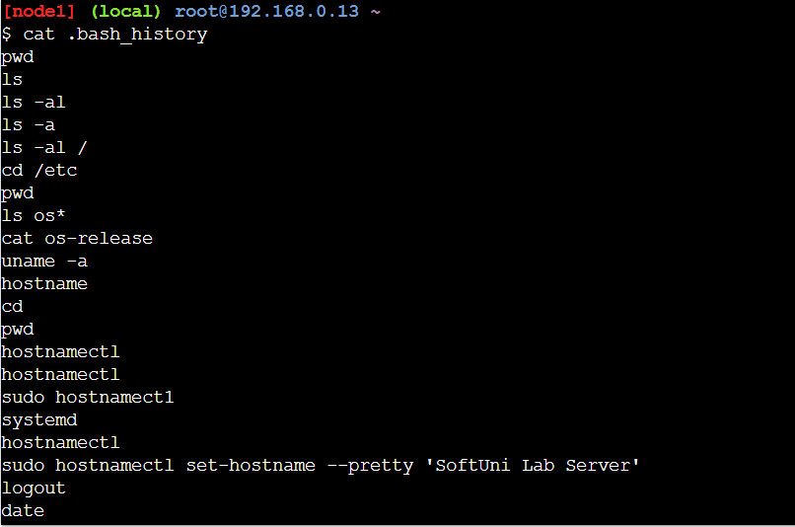
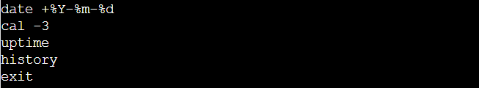
As we can see the last few commands are not here and there is a perfect explanation for this. The reason is that they are kept in a buffer and are stored on the disk only when certain events occur, like session end.

